**CATTLE MANAGEMENT SYSTEM**

**Final Report**

**E-COVER + User Manual**

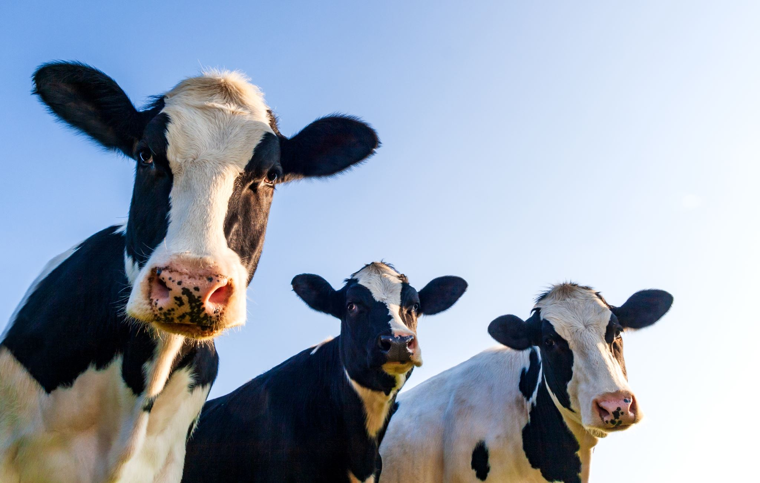

**AUSTRALIA**

**VU Farm LLC.**

**GROUP 6**

**IRAJ PUDASAINI s4647978**

**BRIJESH SONI s4649575**

**ROHAN SHRESTHA s4632768**

**Table of Contents**

Chapter 1: Introduction 4

1.1 Introduction 4

1.2 Aim 4

1.3 Objective 4

1.4 Background of the study 5

1.8 Method 6

1.9 Functional and Non-Functional requirements 6

1.9.1 Functional Requirement 7

1.9.2 Non-Functional Requirement 7

Chapter 2: Implementation and Analysis 8

2.1 Analysis of the project 8

Figure 2: Use Case Diagram 9

Figure 4: Sequence diagram 11

2.2 Implementation Discussion 11

Figure 5: Graphical abstract 13

Figure 6: Different locations of cattle 14

Figure 7: Conceptual Framework 15

Chapter 4: Coding Part 15

4.1 Introduction 15

4.1. Code Structure 15

Figure 8: Dashboard coding part 16

Figure 9: Coding part of edit cattle 16

Figure 10: Cattle insert coding part 18

4.4 User Manual and Result 18

Figure 11: Dashboard output 18

Figure 12: User portal login 19

Figure 13: Admin portal login 20

Figure 14: Cattle details insert 20

Figure 15: New cattle breed entry 21

Figure 16: Map View 21

Figure 17: Database 22

4.5 Trouble Shooting and Discussion 23

Chapter 5: Recommendation and conclusion 25

5.1 Linking with objective 25

5.2 Recommendation and Final Conclusion 25

Reference List 27

**Student Contribution Index:**

**Iraj Pudasaini 33.34%**

**Rohan Shrestha 33.33%**

**Brijesh Soni 33.33%**

**Total 100%**

# Chapter 1: Introduction

## 1.1 Introduction

These days, the role that technology plays in practically every facet of life, no matter where one lives, is considerable. The outcomes of this research will be used as the basis for the development of a ***“cattle management system”*** that has been created by the developers Iraj Pudasaini, Rohan Shrestha and Brijesh Soni. Farmers are an integral component of the social and economic structure of any country.

Even more significantly, the agricultural sector is essential to the functioning of almost every other sector of the economy. An effort of a more modest kind has been started in Australia with the goal of assisting the country's farmers (Poppi, 2018). Farmers who produce cattle but do not have the requisite infrastructure to accurately record their production may now get assistance from researchers and developers who have developed a plan to aid them in doing so. The Farmers and others engaged in this business stand to gain a great deal, not just in terms of their physical well-being but also their financial security.

## 1.2 Aim

The primary or the main aim of this report is to a post-plan implementation of the Capital Management System that was previously made in this project. This report will help in gathering all the data regarding the software work of the cattle management system. further, this report is going to show how the software is working after its proper implementation in the forms of Australia.

## 1.3 Objective

* To find out the proper working of the cattle management system that is made.
* To see if there are any sort of problems with the cattle management system that have been developed.
* To do an in-depth analysis of the software work that is related to the developed cattle management system.

## 1.4 Background of the study

A cattle management system for tracking the live stocks that are present within a farm. This system is made for the farms that are present in Australia. After the deployment of this cattle management system that is planned for this project, it will be able to organize and sort all of the data pertaining to the livestock animals according to age, gender, and any other important criteria included within it. The specific problem that arises when attempting to keep track of farm animals in separate exercise books in the same manner that humans have traditionally struggled to do so reveals itself here.

The problem is similar to the one that arises when attempting to keep track of humans in separate exercise books. If the administrator of the Cattle Management System uses the findings of this research or the product of this application, they will have an easier time developing all of the necessary assumptions and putting in place the appropriate management structure. This will be the case whether or not they use the application. Both of these topics were covered in an earlier discussion. If you utilize this program, it will be very simple for you to manage the whole configuration. In the course of putting this novel approach to cow management into practice, members of the agricultural community came up against a number of challenges.

When the only tools that were accessible were copies and regular exercise books, it was a considerable challenge to maintain accurate performance records utilizing these resources. After conducting a number of in-depth studies, the study team eventually came to an agreement over a plan for enhancing the livestock management system by integrating a variety of technological aspects.

As a direct result of this, a strategy for the management of cattle will be conceived of and put into action as a direct outcome of this study. The usage of this program will make it easier for users and administrators in the agricultural sector to maintain tabs on animals, which will improve the chances of animals surviving and make animal management more efficient. The users of this application will also have an easier time monitoring the animals in their care.

Agriculture on our planet is facing an unprecedented challenge as a result of the fast rise in the global human population. According to the research on agricultural production, by the year 2050, the advantages offered by these products would be used by more than 76 million individuals(Rowe *et al*, 2019).. Over the last several decades, there has been a significant increase in both the amount of food that is consumed and the amount of livestock that is produced as a result of the organization's growing population and improving the level of life. Since the population of Australia is expanding at an alarming rate, any strategy that might help bring the country's cow herds under control would be very much welcomed.

## 1.8 Method

As it has been discussed before, the complete project is a primary project to help the farmers of Australia. The methodology of the system development is based on the software engineering framework and this is used for making the structure of internal control procedure to develop this frame. and this is being consistent with some internal control process and some multiple model tools which will assist in the system development.

To create this software the team of Iraj Pudasaini, Rohan Shrestha and Brijesh Soni made a continuous plan and based on these we have taken the responsibility about the required programming knowledge. The entire project has been evaluated through three areas economics technical and this has been used for some different order to keep the project on track and along with this the evolution progress for the entire system are completed in all the phases. This is going to be the technical phase where we have made the entire software work of managing the cattles.

In the implementation stage some required specifications have been started for the consequence conversation and the productive effort for collecting the design components that have been developed in each of the sections of programming. the complete software work has been done by following all the ethical considerations. To complete this software implementation there are no political violence is and no copyright issues from other resources. we have taken some knowledge about the programming languages that are required to make this application like HTML CSS and PHP. There are no copyright issues and all the data and knowledge has been taken from open sources and journals as well as the study materials that has been provided from the university.

## 1.9 Functional and Non-Functional requirements

Some of the requirements (Functional and Non-Functional Requirements) are unquestionably necessary, whether it is to accomplish the goal of completing this research or to guarantee that the software designed for the center will be effectively installed. There are certain criteria that need to be met for the programme to operate correctly, and these requirements are imposed on both the hardware and the software.

## 1.9.1 Functional Requirement

It was necessary to have either a high-quality desktop computer or a laptop computer with more than 120 gigabytes of solid state storage and at least a minimum of 4 gigabytes of random access memory in order to fulfill the requirements for hardware compatibility.

In addition, the processes required to be ones that are standard for any kind of commercial enterprise. In order to meet the criteria for the software, the software designers need to be conversant in at least one sort of programming language, and they must also have a significant amount of experience with the many programming-related facets. In order to successfully carry out this solution, they are restricting their use of CSS, PHP, HTML, and other JavaScript to the points at which it is unavoidably essential to do so.

In addition, PHP my admin is used for the backend functionality of this cattle management system in order to ensure that the database implementation continues to operate in an efficient manner. The whole user's information that is entered into the administrative portion of the application will be saved in the backend of the system, which means that it will be saved inside the database. This will be the case since the information will be entered by the user.

## 1.9.2 Non-Functional Requirement

Non-Functional Requirements (NFRs) specify the quality features of a software system. They judge software systems on criteria other than responsiveness, usability, security, portability, and other features essential to the success of software systems. Failure to meet non-functional requirements may result in the system failing to meet user needs.

Non-functional requirements in software development can constrain or limit the design of systems across various agile backlogs. Writing non-functional requirements is just as important as functional requirements.

Thus, for this project, the performance requirement, Usability requirement, Serviceability requirement, Security requirement, Data Integrity requirement, Scalability requirement are all met.

# Chapter 2: Implementation and Analysis

## 2.1 Analysis of the project

This is the analysis part or chapter of the entire dissertation that is based on “the cattle management system for farming in Australia”. In this specific part, a few unequivocal references can be utilized to legitimize or make sense of the data gathered according to an elective point of view and to allude to the source. The last segment contains every one of the fundamental information connected with or connected with the fundamental comprehension of this specific point in this survey. The fundamental part is a show that contains a few subsections to comprehend different points connected with research. This part incorporates the essentials of the study, the purposes behind the overview, the thought processes behind the review, the inquiries posed by the review, the mystery of the outline, the explanations for the audit, the significance or significance of the study, and the extension. This specific survey and the different focuses related to this specific research. Every one of the information gathered according to alternate points of view and sources are given to everything in this exceptional segment. There are various theories and models in this segment for managing a few abstract works, and the significant construction of request is additionally brought into this specific piece of the whole exploratory work. The connections between a portion of the elements considered in this test, the lighting results, and the lighting openings are introduced in this specific part.

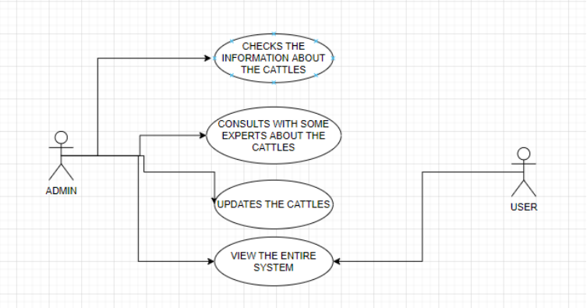

## Figure 2: Use Case Diagram

(Source: Self created in draw.io)

The figure that is present above represents a use case diagram. This use case diagram depicts the use case that is being used in this software work. There are two areas: one is called the admin section, and the other is called the use of the advances portion. Both of these sections may handle the data, for example, the admin section can update the information about the cattle. Regarding the cattle animals, administration may consult with various knowledgeable individuals. In addition, the admin has the ability to change the titles, which includes the ability to remove some animals, add some animals, and update information on the specifics of the animals. The admin who is controlling this cattle management system has the access to every part of the system, but the users those who are using this cattle management system are only access to view this entire system.

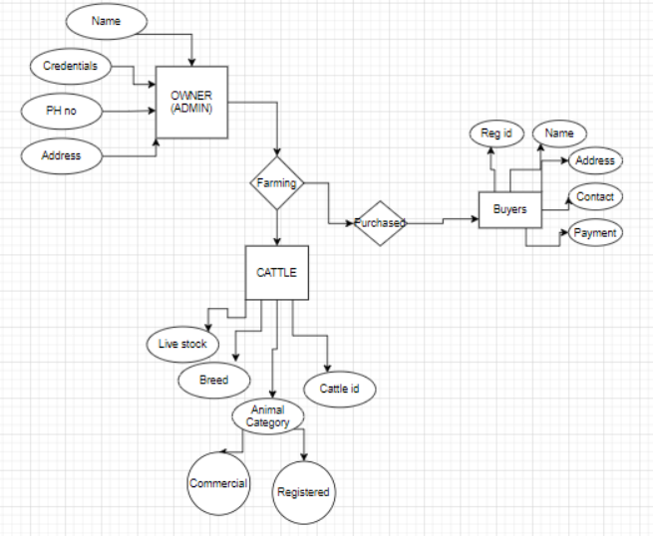

**Figure 3: ER Diagram**

(Source: Self created in draw.io)

The figure that is present above represents the ER diagram or an entity relation diagram for the representation of the cattle management system. Therefore, several qualities, such as the Add phone in the preceding image, such as the primary coordinator of the management system being the owner or the admin, etc., are described as follows: This necessitates having its CE personal credit state in sales such as the phone number, address, and user ID password. The procedure then moves on from the admin to the agricultural system, where it continues on to the cattle. The cattle are required to have certain stocks of the animal breeds, animal classifications, or their cattle IDs.

Therefore, the admin is able to control the entirety of the system, and there is a relationship that exists seen between cattle Management System and the owner, such as the fact that a cattle management system may be owned by one or more owners, or that the owner may have more than one or more cattle farms. Therefore, the relationship that exists between both the cattle Management System as well as the owner is one that is many to many. And as for the connection between the owner and the buyers of the sellers, the relationship between them is also one that is many to many. This is due to the fact that one owner may be required to order more buyers or sellers, while on the other hand, buyers may have one or two owners. Therefore, this is the logic for the existence of many to many connections. The concept of this system is very much simple so that the farms and the farmers do not have any sort of problems while using this cattle management system.

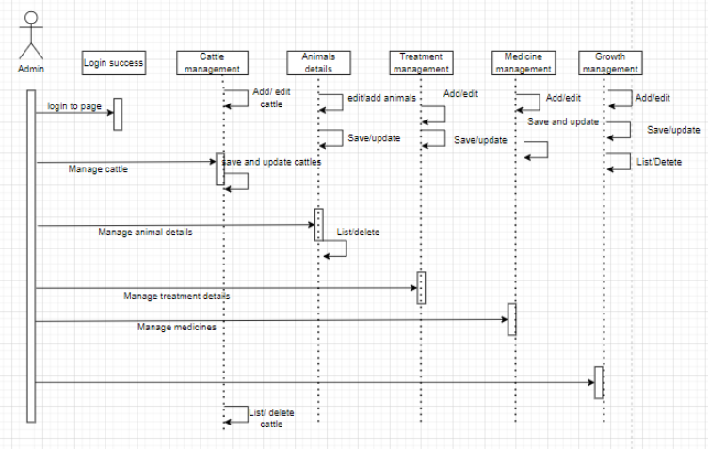

### Figure 4: Sequence diagram

(Source: draw.io)

The figure that is present above represents a sequence diagram that is used to show the sequence of working of the cattle management system.

## 2.2 Implementation Discussion

The major goal of this project was to create an automated livestock management system that would be valuable to farmers who were unable to manually manage their herds. This system would be useful to farmers since it would save the farmers time and effort.

As a result, the researchers have come up with a plan to help farmers in this position by providing them with applications of this kind and others that are quite similar to it. They are now in a position to complete this application in order to be of assistance to the farmers of Australia as a consequence of their more hopeful perspective and enhanced practices. The application is divided into two parts: the first is for administrators to manage the programme, and the second is for regular users. In the administration panel, the administrator may keep track of the animals according to their breeds, ages, and sexes, as well as add new animals, update existing animals, remove existing animals, and add new information about the animals.

The Admin area is private and inaccessible to all other users. Additionally, the administrator has the power to sell extra cattle animals or buy new ones using this component of the platform. The users of this application, on the other hand, are only able to observe the number of animals that are present on the farm, the number of cattle that fall into the same category, the weights of the animals, the ages of the animals, the gender of the animal, and how they can monitor the inter-applications of the agricultural system. And the results of the inter-experiment revealed that farmers are able to handle this application, and it is easily manageable for this cattle management farming system.

This was shown by the results of the experiment. This became clear once the independent experiments had been carried out. It is possible for the administrator to keep track of each and every animal that is added to the database. During the whole process of designing the database implementation, the standard PHP connector was used. The administrator of this management system will be the one to insert new entries into the database after it has been loaded with all of the pertinent information, including the track.

In the previous 60 years of debate, all of the relevant code components, in addition to the output area, have been covered. After completing all of the code files, implementing all of the CSS as well as the HTML files, and adding the JavaScript, it was cleaned up to ensure that the whole coding component ran without any errors. This was accomplished since there were no errors in any of the code that was done. In addition to that, the expansion of the human population is happening at a very quick pace. This specific kind of business is also increasing at an alarmingly rapid rate. Researchers have developed a form of website that has the potential to play a significant role in the business of cattle as a result of their understanding of the needs of both buyers and sellers of cattle. This knowledge was gained after doing research into the cattle industry.

It will be easy for the administrator to handle all of the activities in a way that is uncomplicated since the foundation of the whole livestock management system is basically an application that operates on the web. No matter what sort of transaction takes place, the administrator will have the capability to purchase and sell a broad variety of animals and calves in a quick and safe way. Anyone who has access to the internet may easily get started with the process of learning how to make use of this complete system since it is so easy to get information online. While you are using this software, the administrator does not need to take a seat or simply control the activity that is typed into you on some papers. Both of these tasks are performed automatically by the programme. In addition, there is no need for them to carry out any computations or do any kind of cost analysis, either manually or only on select papers. As long as the user has access to the internet, they can run this programme whenever they want, wherever they want. The only requirement is an internet connection. Because of this technology, users will have the ability and independence to operate the whole system by virtue of a single online interface. The overall objective of the project is to provide buyers with a variety of services, such as the option to pick the cattle of their choice to buy or sell any of their cattle just on the web at the price that they like.

The purpose of the project is to provide buyers with a variety of services, such as the option to pick the cattle of their choice to buy or sell any of their cattle just on the web at the price that they like. There are two types of cattle available for your consideration.

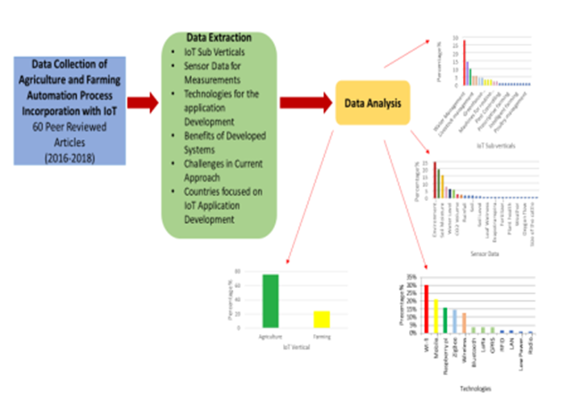

### Figure 5: Graphical abstract

(Source: Madushanki *et al* 2019)

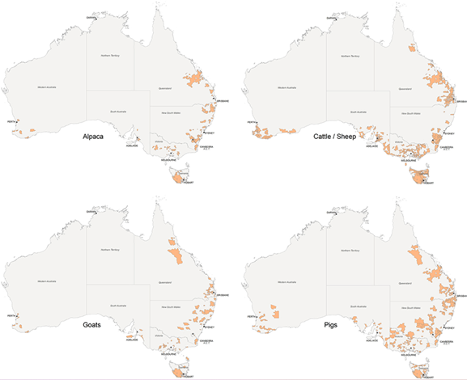

### Figure 6: Different locations of cattle

(Source: Gargiulo *et al,* 2018)

### Figure 7: Conceptual Framework

(Source: Self-created)

# Chapter 4: Coding Part

## 4.1 Introduction

The researchers Iraj Pudasaini, Rohan Shrestha and Brijesh Soni have developed a wonderful application that is really remarkable in its scope and scope of accomplishment. In order to design this application, the developers conducted a significant amount of research. Any form of management system is compatible with this application that is written in PHP.

## 4.1. Code Structure

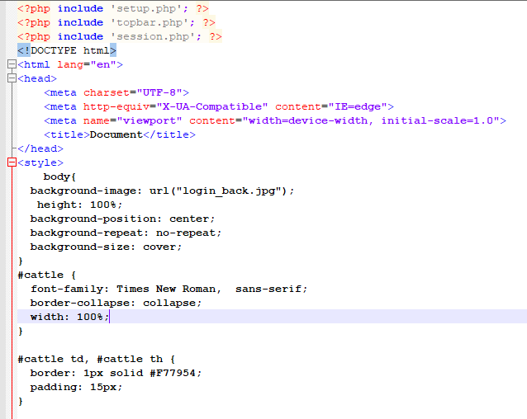

### Figure 8: Dashboard coding part

(Source: Notepad ++)

The figure that is present above represents the PHP code that is used for designing the dashboard. The code that will be used to create the dashboard using the PHP programming language is shown in the figure. In addition to that, it has been used for the creation of tables, the authoring of various parts, and the utilization of CSS style sheets in order to either stop the background image or add certain styles.

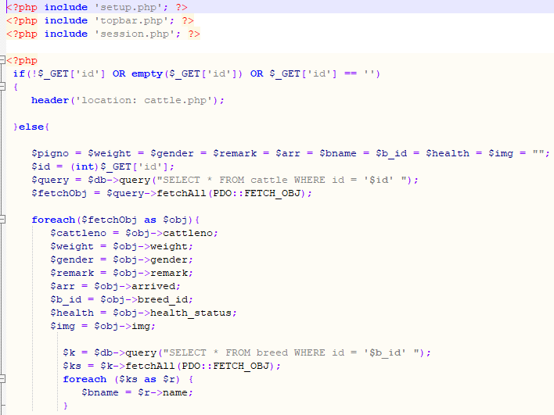

### Figure 9: Coding part of edit cattle

(Source: Self-created in Notepad++)

The figure that is present above represents the coding part of the edit cattle section of the cattle management section. It has been determined where the code for the collection of relevant data of the livestock management system is located. Moreover, it has been discovered that the number of cattle, the poet of the cow, the gender of the generation reading it, and the health condition have all been displayed in the coding section of And in accordance with the work that has been carried out in notepad ++. It has been determined where the code for the edit page of the livestock management system is located.

Moreover, it has been shown that the number of cattle, the breed of the cow, the gender of the month of breed and the health condition have all been displayed in the coding section of Anant in accordance with the work that has been carried out in notepad ++ (Meshesha et al, 2019). The proposed method makes it possible to examine not just cattle but also all other animals, and it also makes it possible for parties to reach an agreement online. The system is developed solely with the company and its clients in mind, and it has an appealing user interface. It is also very easy to operate and does not need any prior knowledge or training on the part of the administrator. The owner is freed of the laborious work on paper by engaging and performing this method.

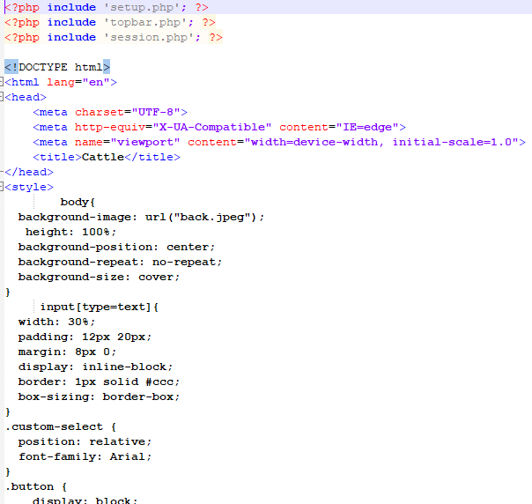

### Figure 10: Cattle insert coding part

(Source: Notepad++)

The figure that is present above represents the php coding part of the cattle management system that isn't being used to insert the live stocks or the cattles of the farm. This figure shows all the necessary details regarding the livestock or the cattles that are present within the farm.

## 4.4 User Manual and Result

The project demonstration and Presentation will have all the details about the application.

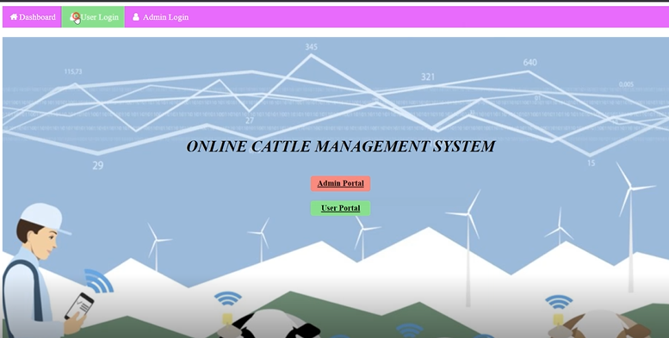

### Figure 11: Dashboard output

(Source: Self-created)

The diagram serves as the primary dashboard for the cattle management system, on which all of their statuses are shown. The first one is the administrator's dashboard, and the one after that is the user's dashboard. The administrator of this title management system has access to the program via the admin portal, allowing him to make use of it in a manner that corresponds to his level of comprehension. And in the second choice, there is a user portal where the customer can log in with his ID and password and see all of the different kinds of cattle.

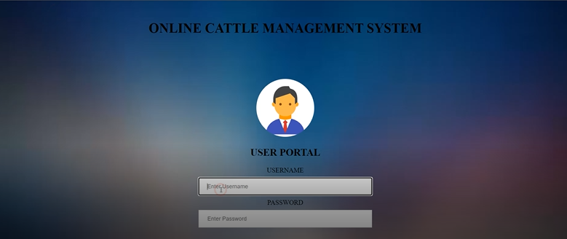

### Figure 12: User portal login

(Source: Self-created)

Above you can see the user interface where regular users of the livestock management system input the username and password they were given by the system administrator. User access to the subsequent page is contingent upon entering a valid login and password. As advertised on the user portal, the administrative portal has identical features and functions, including the ability for the administrator to log in to the system using the same username and password as those used by end users.

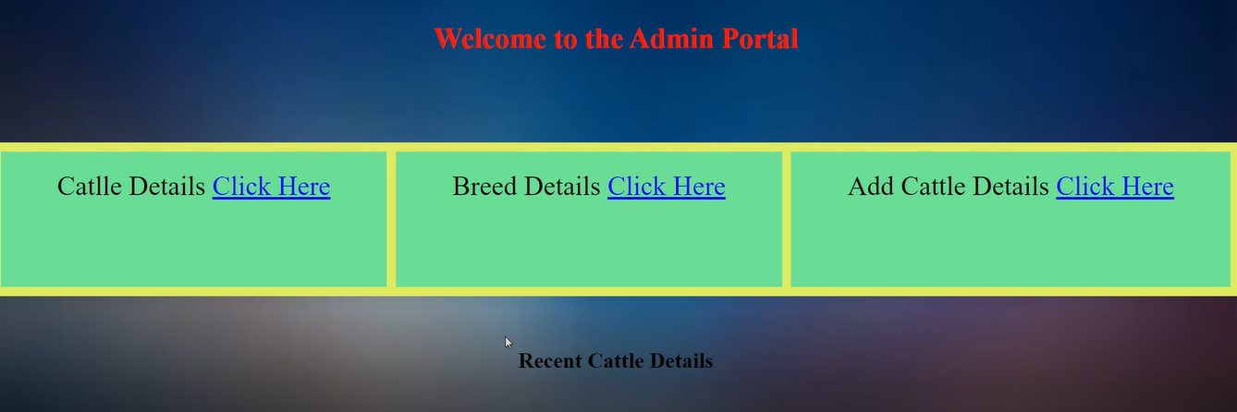

### Figure 13: Admin portal login

(Source: Self-created)

After providing the correct user id and password, the admin is able to enter the admin portal. There are three options shown here for the cattle details. If the admin wishes to view the cattle specifics, we need to click just on click here, and the next force is detailed, and another is at the cattle details. The admin can check the Beatles by using these sections. The figure above shows the admin portal. And the administrator is able to look at the cattle and the matching will be shortly included in the following numbers thanks to the specifics of the livestock.

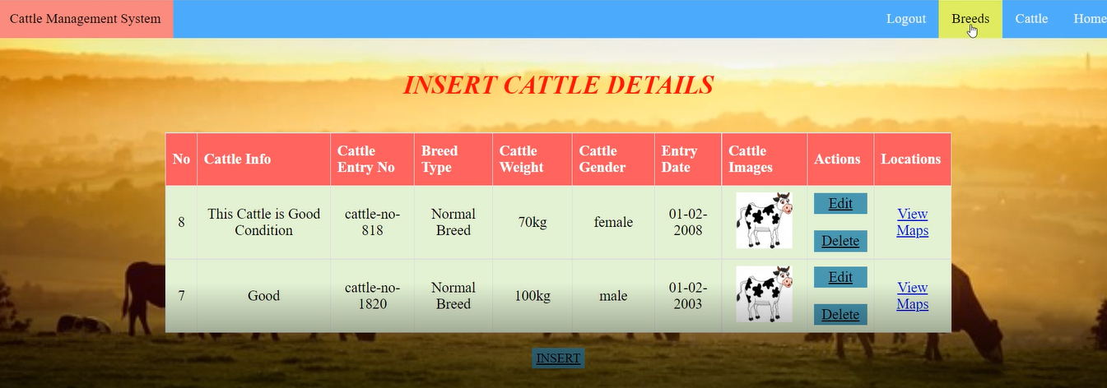

### Figure 14: Cattle details insert

(Source: Self-created)

A link for the cow number, breed, and kind of each has been shown, and the admin has the ability to alter or remove the cattle presented here. Animals that have been sold, retired, or otherwise removed from use on the farm might make room for new cattle. (Biasato *et al.* 2019).

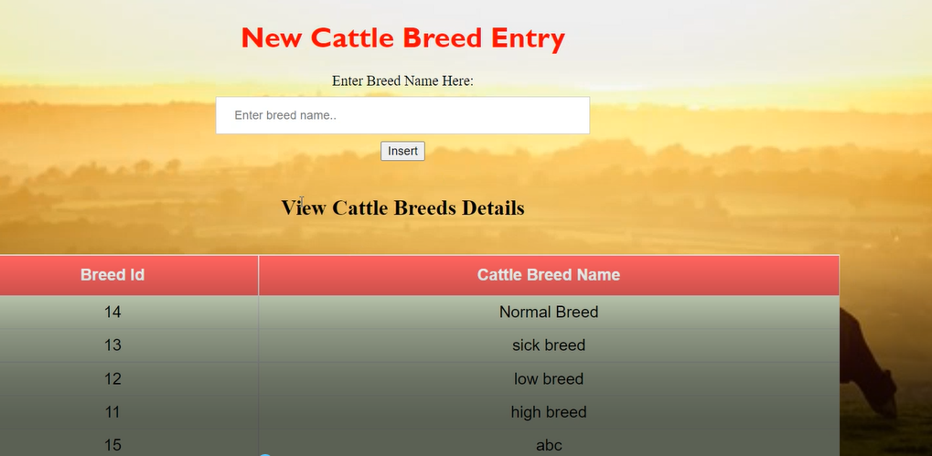

### Figure 15: New cattle breed entry

(Source: Self-created)

If the admin wants to look at the new cattle breed then the admin has to put the name into the search or in the image that is being shown in the upper section to enter the name and can add the corresponding breed ID with the quality of the great like normal breed low breed hybrid and so on.

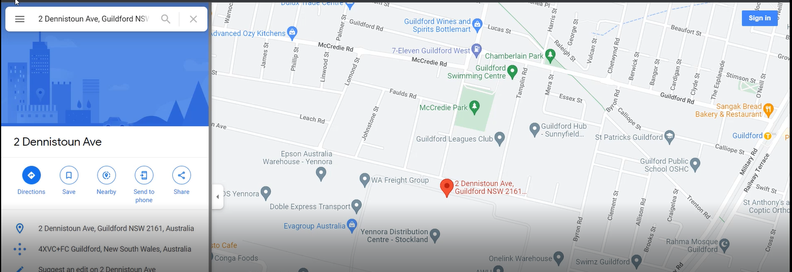

### Figure 16: Map View

(Source: Self-created)

This is a map of Australia's agricultural industry, courtesy of Capital Management. Researchers and other students in Sydney, Australia, chose to create this project or application to aid the farming sector based on the specific needs of the agricultural industry there. Business in many Australian towns, including Sydney, centers on the sale of cow- and cattle-related items, as well as the maintenance and sale of related capital equipment and infrastructure. (Widodo *et al.* 2022).

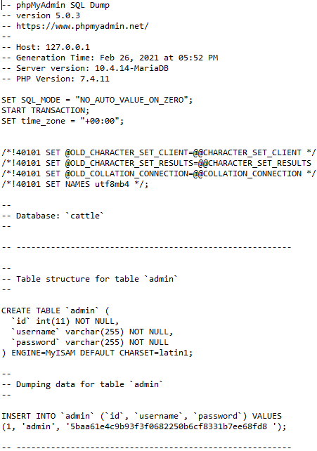

### Figure 17: Database

(Source: Notepad)

The figure is the database implementation with all the possible characteristics that are provided in the database for the user login the password is user and user ID is used and for the admin portal the user ID is admin and the password is also add me and the database name is cattle. the user will add details according to the group age weight so all the details will be saved in the database section and while some of the cattle serving deleted it will also be deleted from the database.

## 4.5 Trouble Shooting and Discussion

The researchers have made a plan to help those farmers by providing them with such kind of application like this. So after taking the positive thinking and better approaches they are now able to complete this application to help the farmers (MEHTA, 2018). As it has been discussed before that in the application there are two sections one is admin section and other users in the admin section the admin can add the animals update the animals delete the animals and can keep the track of them according to their breeds age and sex. and through this part of the application, the admin can sell or buy some more cattle animals.

On the other hand, the users of this application just can see how many animals are available in the fa how many cattle are of the same category, what are their weights, what are the ages, what is the gender of the animal, and they just can look after the inter-application of the farming system. And after making the inter experiment the result shows that the farmers can easily handle this application and it is easily manageable for this farming system. the admin can keep the track of each and every animal in the database.

The normal PHP connector has been used to make the database implementation and all the details and the track will be shaped into the database which will be added by the admin of this management system. All the required coding sections and the output section are discussed in the above. The finding part of this chapter shows how the data has been collected from several sources and how the required data has been used to make this entire dissertation.

After completing all the coding files and making the implementation of all the HTML and CSS files along with the JavaScript four sons it has been cleared so that the entire coding part has run errorless (Qiao *et al.* 2021). And the population is growing in a very fast way. This kind of business is also growing at a rapid rate. So after understanding the needs of the cattle buyers and the seller, researchers have made the design this kind of website which can play a vital role in the cattle business. The entire project of the cattle management system is mainly a web-based application, and this will allow the administrator to handle the entire activities in an easy way. Admin can purchase or sell various kinds of animals and cattle in any quick process and the process will be safe too.

Making use of the internet anyone can quickly get learning about the use of this complete system. While using this application the administrator doesn't need to seat or just manage the enter activity into you just some papers or do not need to to make the calculations or make the cost analysis just into the papers or manually. The user can use this application anytime anywhere just with the use of a simple internet connection. This technology will provide users with the ability and independence to operate the overall system through a single web interface (Budisatria *et al.* 2019). The project's goal is to supply purchasers with different services such as selecting the cattle of the choice to purchase or sell.

# Chapter 5: Recommendation and conclusion

## 5.1 Linking with objective

With this application, other users can benefit from the help by the developers Iraj, Rohan and Brijesh. As the above chapter shows everything about the implementation process it has been clearly shown that the taking objectives are fulfilled and the researchers are able to complete the software implementation (Easter *et al.*  2018). To keep track of all the animals and save them in the database. To make the group the cattle with this age, breed, sex, and on. When all the objectives are fulfilled there is an admin and user panel the users are getting help with using this application. Secondly, the tracks of those cattle animals are being saved. The farmers are really happy after getting this kind of application.

## 5.2 Recommendation and Final Conclusion

HTML, CSS, PHP, and JavaScript, have been used in the completion of particular duties that are necessary. Programming was used in the process of constructing the system for controlling livestock; the system itself was built using programming. The employment of a database has enabled the records to be maintained up to date, and the use of phpMyAdmin has assisted the programmer in building a connection that is included inside the database. It is possible to supply some improved ideas about the application in order to make the process of performing research a technique that is both more effective and takes less time. This can be accomplished via the use of a method that is known as the research cycle. There is a need for a very modest number of new developers or programmers, and each of these employees is expected to have a more comprehensive understanding of the various programming languages (Kasem et al, 2018).

After then, there is a chance that the task may have been finished in a shorter amount of time than originally anticipated. It would have been better to utilize some other computer languages, such as C# or Java, while building the system for managing cattle. This would have allowed for a more streamlined development process.

The following languages are some examples of those that might have been helpful to know. It is feasible to make use of AWS to save the cattle's track record information in order to make it more readily accessible in the event that it has to be retrieved. The cloud infrastructure will be considerably more secure and will not have any worries with data leaking, despite the fact that it will be less costly to monitor everything and every detail. On the other hand, this application to assist cattle farmers is extremely unusual in terms of both its level of usefulness and the quality of the labor that went into developing it. The process of capturing and reporting production data is something that has to be streamlined in order to achieve this aim. (Crociati *et al.*  2022).

# Reference List

Kasem, S., Saleh, M., Qasim, I., Hashim, O., Al Karar, A., Abu‐Obeida, A., Gaafer, A., Hussien, R., AL‐Sahaf, A., Al‐Doweriej, A. and Bayoumi, F., 2018. Outbreak investigation and molecular diagnosis of lumpy skin disease among livestock in Saudi Arabia 2016. *Transboundary and emerging diseases*, *65*(2), pp.e494-e500.

Kelley, J.M., Rathinasamy, V., Elliott, T.P., Rawlin, G., Beddoe, T., Stevenson, M.A. and Spithill, T.W., 2020. Determination of the prevalence and intensity of Fasciola hepatica infection in dairy cattle from six irrigation regions of Victoria, South-eastern Australia, further identifying significant triclabendazole resistance on three properties. *Veterinary Parasitology*, *277*, p.109019.

Kovácsné Koncz, N., Béri, B., Deák, B., Kelemen, A., Tóth, K., Kiss, R., Radócz, S., Miglécz, T., Tóthmérész, B. and Valkó, O., 2020. Meat production and maintaining biodiversity: Grazing by traditional breeds and crossbred beef cattle in marshes and grasslands. *Applied Vegetation Science*, *23*(2), pp.139-148.

Madushanka, R., Wirasagoda, H. and Halgamuge, M., 2019. Adoption of the Internet of Things (IoT) in agriculture and smart farming towards urban greening: A review.

Martinez, C.C., Maples, J.G. and Benavidez, J., 2021. Beef cattle markets and covid‐19. *Applied Economic Perspectives and Policy*, *43*(1), pp.304-314.

MEHTA, D.N.K., 2018. 1. PREVALENCE OF ECTOPARASITE INFESTATIONS ON CATTLE IN AMRELI DISTRICT WESTERN INDIA by DR. NIMESH K. MEHTA. *LIFE SCIENCES LEAFLETS*, *100*, pp.1-to.

Meshesha, D.T., Mohammed, M. and Yosuf, D., 2019. Estimating carrying capacity and stocking rates of rangelands in Harshin District, Eastern Somali Region, Ethiopia. *Ecology and Evolution*, *9*(23), pp.13309-13319.

Munidasa, S., Eckard, R., Sun, X., Cullen, B., McGill, D., Chen, D. and Cheng, L., 2021. Challenges and opportunities for quantifying greenhouse gas emissions through dairy cattle research in developing countries. *Journal of Dairy Research*, *88*(1), pp.3-7.

Muñoz, E.C., Andriamandroso, A.L.H., Blaise, Y., Ron, L., Montufar, C., Mafwila Kinkela, P., Lebeau, F. and Bindelle, J., 2020. How do management practices and farm structure impact productive performances of dairy cattle in the province of Pichincha, Ecuador.

Nur-E-Alam, M., Hoque, M.N., Ahmed, S.M., Basher, M.K. and Das, N., 2020. Energy engineering approach for rural areas cattle farmers in Bangladesh to reduce COVID-19 impact on food safety. *Sustainability*, *12*(20), p.8609.

Panjaitan, T., Waldron, S., Halliday, M.J., Ash, A., Morris, S.T. and Shelton, H.M., 2019. Adoption of leucaena-based feeding systems in Sumbawa, eastern Indonesia and its impact on cattle productivity and farm profitability. *Tropical Grasslands-Forrajes Tropicales*, *7*(4), pp.428-436.

Paz-Penagos, H., 2019. Use of radio telemetry to determine presence of cattle stress indicators before slaughter. *Revista Colombiana de Biotecnología*, *21*(1), pp.144-152.

Poppi, D.P., Quigley, S.P., Silva, T.A.C.C.D. and McLennan, S.R., 2018. Challenges of beef cattle production from tropical pastures. *Revista Brasileira de Zootecnia*, *47*.

Qiao, Y., Kong, H., Clark, C., Lomax, S., Su, D., Eiffert, S. and Sukkarieh, S., 2021. Intelligent Perception-Based Cattle Lameness Detection and Behavior Recognition: A Review. *Animals*, *11*(11), p.3033.

Qiao, Y., Su, D., Kong, H., Sukkarieh, S., Lomax, S. and Clark, C., 2019. Individual cattle identification using a deep learning based framework. *IFAC-PapersOnLine*, *52*(30), pp.318-323.

Rowe, E., Dawkins, M.S. and Gebhardt-Henrich, S.G., 2019. A systematic review of precision livestock farming in the poultry sector: Is technology focussed on improving bird welfare?. *Animals*, *9*(9), p.614.

Salvador, L.C., O'Brien, D.J., Cosgrove, M.K., Stuber, T.P., Schooley, A.M., Crispell, J., Church, S.V., Gröhn, Y.T., Robbe‐Austerman, S. and Kao, R.R., 2019. Disease management at the wildlife‐livestock interface: Using whole‐genome sequencing to study the role of elk in Mycobacterium bovis transmission in Michigan, USA. *Molecular Ecology*, *28*(9), pp.2192-2205.

Scott, H.M., Acuff, G., Bergeron, G., Bourassa, M.W., Gill, J., Graham, D.W., Khan, L.H., Morley, P.S., Salois, M.J., Simjee, S. and Singer, R.S., 2019. Critically important antibiotics: criteria and approaches for measuring and reducing their use in food animal agriculture. *Annals of the New York Academy of Sciences*, *1441*(1), pp.8-16.

Sevane, N., Martínez, R. and Bruford, M.W., 2019. Genome‐wide differential DNA methylation in tropically adapted Creole cattle and their Iberian ancestors. *Animal genetics*, *50*(1), pp.15-26.

Singh, A.K., Singh, P., Girish, C.E., Kisku, U., Singh, B. and Sheik, S.A., 2022. Centralized need for smartphones in utilizing technologies developed for improving performances of dairy cattle: A review. *Indian Journal of Animal Health*, p.2.

Wallbott, L., Siciliano, G. and Lederer, M., 2019. Beyond PES and REDD+: Costa Rica on the way to climate-smart landscape management?. *Ecology & Society*, *24*(1), p.24.

Widodo, O.S., Etoh, M., Kokushi, E., Uno, S., Yamato, O., Pambudi, D., Okawa, H., Taniguchi, M., Lamid, M. and Takagi, M., 2022. Practical Application of Urinary Zearalenone Monitoring System for Feed Hygiene Management of a Japanese Black Cattle Breeding Herd—The Relationship between Monthly Anti-Müllerian Hormone and Serum Amyloid A Concentrations. *Toxins*, *14*(2), p.143.

Xu, B., Wang, W., Falzon, G., Kwan, P., Guo, L., Sun, Z. and Li, C., 2020. Livestock classification and counting in quadcopter aerial images using Mask R-CNN. *International Journal of Remote Sensing*, *41*(21), pp.8121-8142.

Yusuf-Isleged, M.A., Prevalence and Associated Risk Factors of Bovine Mastitis on Dairy Cattle in Mogadishu Somalia.